Student Name | G.Manasa
Student Registration Number | 241U1R3007 | Class &Section: CSE(DS)
Study Level: UG/PG | UG | Year &Term: I & II
Subject Name | Digital Electronics

Name of the Assessment | Reflective Journal -4
Date of Submission | 07/07/2025

Reflective Journal Template
Journal Entry Guidelines | Description
1. Experience (Class Content) | Briefly describe the topics or concepts discussed during the class.
2. Feelings (Emotional Reactions) | Share your emotional reactions and thoughts during the class.  How did you feel while learning this theory?  Did the class evoke specific emotions or questions?
3. Learning (Key Insights) | Reflect on what you learned from the class.  Highlight the key insights or fundamental concepts you gained from the class.
4. Application (Practical Use) | Describe how you plan to apply the theory you've learned in real-life situations or in your academic/career endeavours.  Explain the practical utility of this theory.

Sample Journal Entry

Date | 07-07-2025
Journal Entry Topic | Switching function-II
1. Experience (Class Content) | Today in class, we learned about a new topic in digital electronics called Karnaugh Map or K-Map. At first it looked a bit confusing to me because it had tables with numbers and binary values. But when the teacher explained it slowly step by step I started to understand it better.  The teacher said that K-Maps help us to make long and tricky logic expressions shorter and easier. These expressions are called Boolean expressions, and they are used in digital circuits.  We learned how to draw K-Maps with 2, 3, and 4 variables. I found it interesting that instead of using normal binary numbers, we use something called Gray code to fill the map. It was fun, like solving a puzzle we grouped the 1s together to make the logic simple. We also did some practice problems in class, and when I got the right answer I felt really happy and proud.
2.Feelings (Emotional Reactions) | At the beginning, I felt a bit nervous and overwhelmed because it looked difficult, especially with the 3-variable and 4-variable K-maps. But later when we solved examples together I started feeling more confident and excited. I felt happy when I was able to simplify one expression by grouping cells myself. It gave me a sense of achievement and made me feel more confident about learning digital electronics.
3. Learning (Key Insights) | 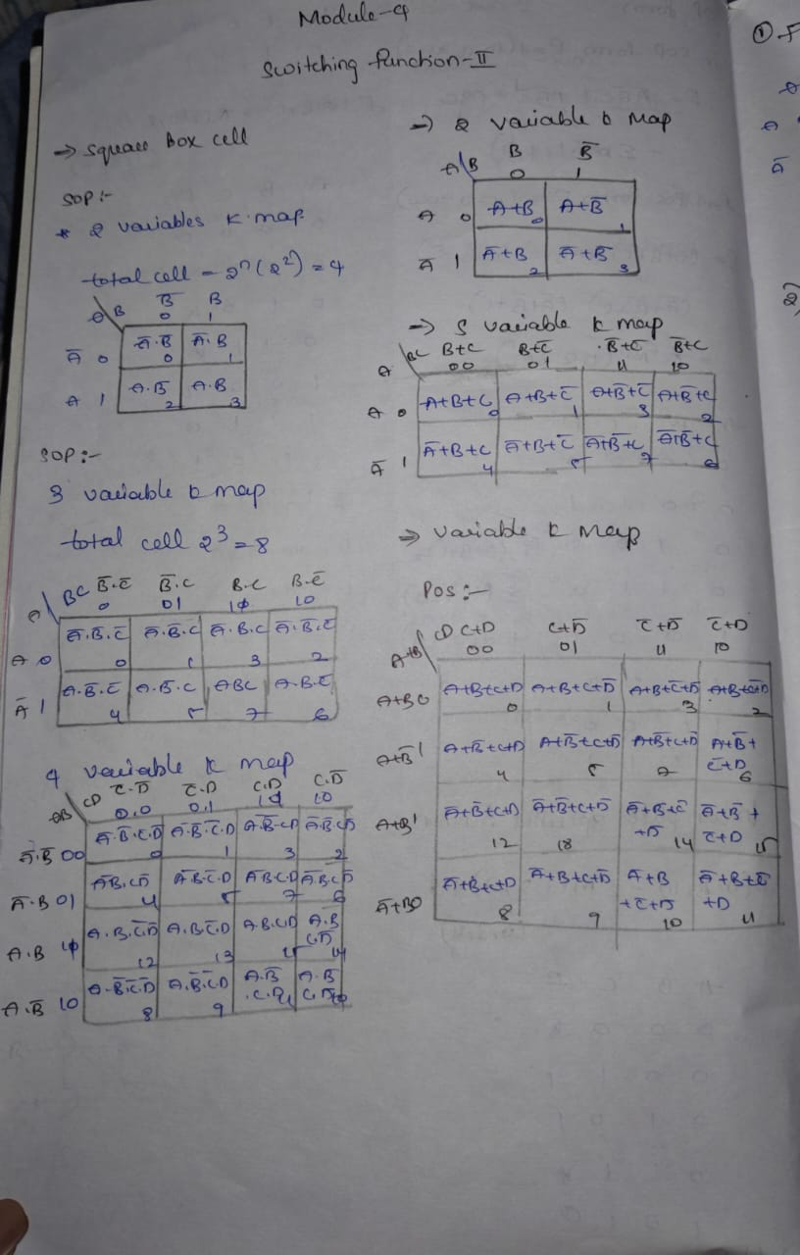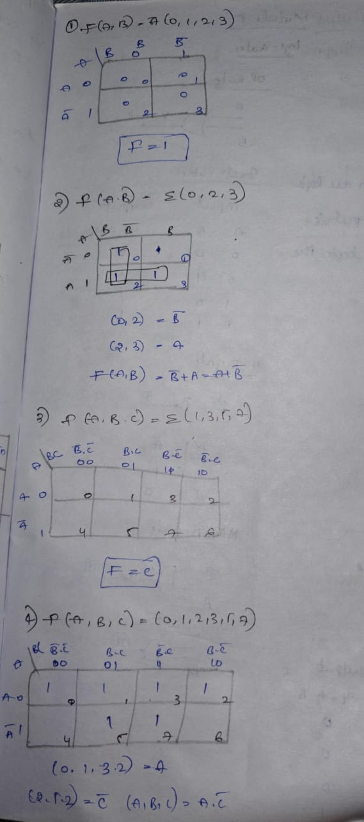
4. Application (Practical Use) | Karnaugh Maps are very useful in real-world digital systems. Here are some areas where K-maps are used:  - Computer and Microprocessor Design – Used to simplify logic inside CPUs and chips.  - Traffic Light Controllers – To make logic simpler and efficient.  - Mobile Phones and Gadgets – K-maps help in making smaller and faster circuits.  - Error Detection & Correction – In memory devices, communication systems, etc.  - Digital Calculators & Logic Devices – For building circuits that perform logic operations.  By using K-maps, engineers can design more efficient circuits that save energy, space, and cost.
Conclusion | This class on Karnaugh Maps was very useful and gave me new knowledge about how digital circuits work. I learned how complex logic expressions can be made simple using a visual method like K-map. At first it looked difficult but after solving some examples I found it fun and easy to understand.  This topic helped me improve my logical thinking and problem-solving skills. I now feel more confident in understanding digital systems and want to explore more about logic design. Learning about such tools also made me realize how smart methods like this are used in real-life devices that we use every day.

